Clerk to the Council: Emily Simpson
Tel: 07881714526
e-mail: ashurstclerk@outlook.com

TO: ALL MEMBERS OF ASHURST PARISH COUNCIL

Councillors are respectfully summoned to attend the meeting of Ashurst Parish Council on Thursday 21st July 2022 at 7.30pm at Ashurst Village Hall for the transaction of the business on the Agenda below.

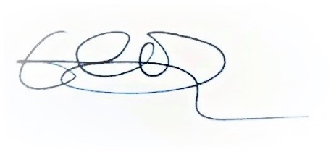
Emily Simpson
Clerk to the Council
16th July 2022

AGENDA

To discuss any questions submitted by the public.

- Apologies for Absence.
- Declaration of Members’ Interests, notification of changes to Members’ Interests, and consider any requests for dispensation.
- Approve the Minutes* of the meeting of 19th May 2022: The minutes, subject to any amendments, to be approved and signed as a true record of the meeting.
- Reports from District & County Councillors.
- Outstanding Actions: To report on actions brought forward from the last meeting.
- Recreation Ground Matters:
- To receive a report on the Recreation Ground Trust’s income and to approve future expenditure.
- To consider three electrical quotes for works relating to the recent EIC Report.

- To note the Legionnaires report and discuss recommended works and training.

- To receive an update on recent developments from Cllr Fischel.

- Community Climate Fund

To discuss Horsham District Council’s grant funding to Parish Councils to support projects that tackle climate change.

- Planning Applications

To comment on planning applications received from Horsham District Council.

- Planning Decisions from HDC

To receive decisions on planning applications from Horsham District Council.

- Payments and bank reconciliations

(a)To review the schedule of payments since the last meeting (19th May 2022) and the latest bank reconciliations (May and June).

(b)To receive a report on the Council’s income.

(c)To discuss online banking and approve the Clerk as a signatory.

- Parish Online

To consider the annual subscription renewal of Parish Online.

- WSALC Update

To receive any updates from WSALC including training programme.

- HALC Update
- To receive a general update from Cllr Fischel.
- To receive an update on the Knepp Wildland initiative, Weald to Waves, and to consider APC’s response (Cllrs Headley, Knight and Fischel).

- Local Plan

To receive an update from Cllr Fischel.

- Grants

To review any grant applications.

- GDPR

Reminder to delete all emails over 6 months old.
- Correspondence

To discuss recent significant correspondence, either by letter or email, and respond as appropriate.
- To note a report on the application of a 12 tonne weight restriction on the B2135.
- Reports from Outside Bodies

To receive any reports from external organisations.
- Information Items

To receive information and items for the agenda at future meetings.

Date of the next Meeting of the Council: Thursday 15th September 2022

*Documents circulated to all Councillors with the agenda/emails previously forwarded.

