Your waste collection service is changing – are you ready?
From February 2018 Horsham District Council will be rolling out changes to your waste and recycling collection service.
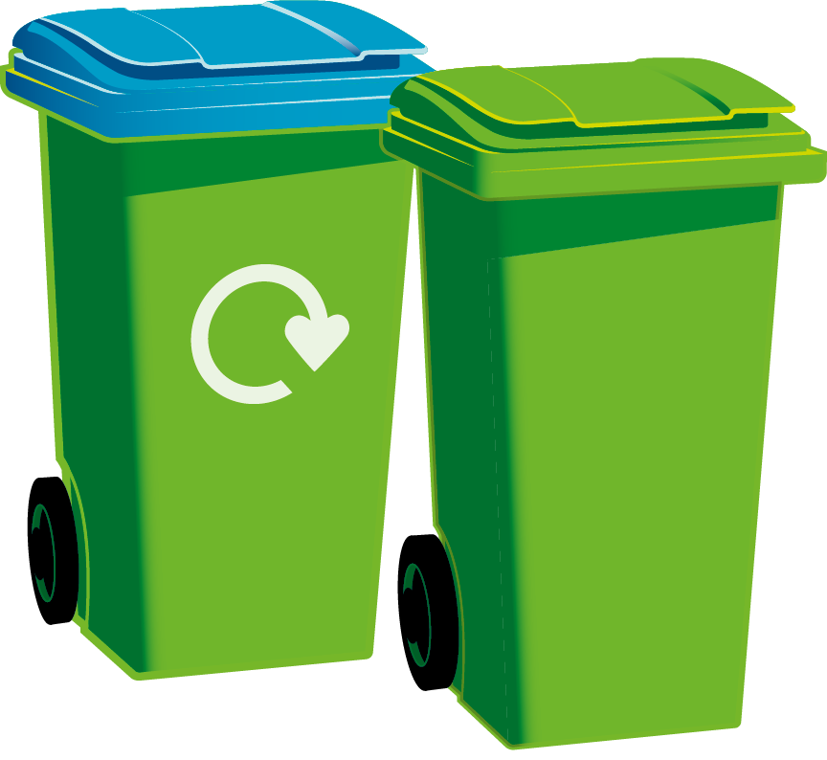
What’s changing?
Your recycling will be collected one week and your household waste will be collected the same day the following week. Garden waste will continue to be collected fortnightly for those who have subscribed to this service.
All households will receive information in mid January explaining the changes and giving each household their new personalised collection dates. After that you can also remind yourself of your new collection dates via your online personalised collections calendar: www.horsham.gov.uk/bincalendar
Why are we making these changes?
The government has set a mandatory national recycling target of 50% by 2020. If we fail to meet this we will incur financial penalties. Currently the Horsham District recycles 44% of its waste so we are close, but we know we can achieve more because investigation into our waste collections have shown that on average 20% of what we currently throw away in our household waste bins can be put into our mixed recycling bin.
Over three quarters of local authorities now operate this alternate weekly collection service with some of these councils seeing a resulting increase in recycling of up to 9%. Introducing these changes will also save the council money which will enable us to maintain essential public services against a backdrop of declining government income.
If you have any questions about this please visit our website in the first instance which will answer most of your queries and includes a Frequently Asked Questions section.
Find out more
New waste and recycling collection service
www.horsham.gov.uk/newbincollections
Tel: 01403 733144
Recycling top tips
www.horsham.gov.uk/bins/thinkbeforeyouthrow

