Clerk to the Council: Emily Simpson
Tel: 07881714526
e-mail: ashurstclerk@outlook.com

TO: ALL MEMBERS OF ASHURST PARISH COUNCIL

Councillors are respectfully summoned to attend the meeting of Ashurst Parish Council on Thursday 24th November 2022 at 7.30pm at Ashurst Village Hall for the transaction of the business on the Agenda below.

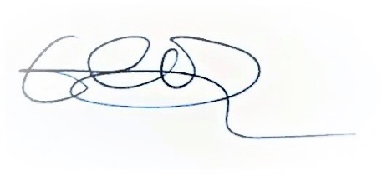
Emily Simpson
Clerk to the Council
20th November 2022

AGENDA

To discuss any questions submitted by the public.

- Apologies for Absence.
- Declaration of Members’ Interests, notification of changes to Members’ Interests, and consider any requests for dispensation.
- Approve the Minutes of the meeting of 21st July 2022: The minutes, subject to any amendments, to be approved and signed as a true record of the meeting.
- Reports from District & County Councillors.
- Outstanding Actions: To report on actions brought forward from the last meeting.
- Recreation Ground Matters:
- To receive a report on the Recreation Ground Trust income and expenditure.
- To receive a Legionnaire’s update.
- To receive an update on the recent electrical works.
- To receive an update on the Ashurst United FC agreement.
- To receive a general update from Cllr Fischel.

- Broadband in Ashurst
- To receive an update on Broadband in Ashurst.

- Planning Applications

To comment on planning applications received from Horsham District Council.
- DC/22/1766 Gratwicks House Church Lane Ashurst Steyning West Sussex BN44 3AR

Proposal: Installation of 4no additional solar panel arrays.

- Planning Decisions from HDC

To receive decisions on planning applications from Horsham District Council.

- Payments and bank reconciliations

(a)To review the schedule of payments since the last meeting (21st July 2022) and the latest bank reconciliations (July and August).

(b)To receive a report on the Council’s income.

- Budget 2023-24

To consider the budget proposal for 2023-24.

- Policies

(a) To review and adopt the latest NALC Council’s Standing Orders

(b) To review and adopt the latest NALC Financial Regulations

(c) To review the Council’s Grants Policy

(d) To review the Council’s Risk Assessment

- WSALC/NALC Update

To receive any updates.
- NALC Civility & Respect pledge.
- To update on the latest pay scales released by NALC earlier in the month.

- Winter Maintenance Plan
To discuss and update the Winter Maintenance Plan in Ashurst.

- HALC Update

To receive a general update from Cllr Fischel.

- Rampion

To receive an update from Cllr Knight.

- Boundary Commission

To consider and respond to the new Boundary review proposal.

- Flooding on Peppers Lane

- Grants

To review any grant applications.

- GDPR

Reminder to delete all emails over 6 months old.
- Correspondence

To discuss recent significant correspondence, either by letter or email, and respond as appropriate.
- Wilder Horsham District workshop – Thursday 9th February 2023 10am-4pm Ashington Community Centre.
- Reports from Outside Bodies
- Information Items

To receive information and items for the agenda of future meetings.

- Future meeting dates for 2023

To propose and agree Council meeting dates for the year ahead.

Date of the next Meeting of the Council: TBC

