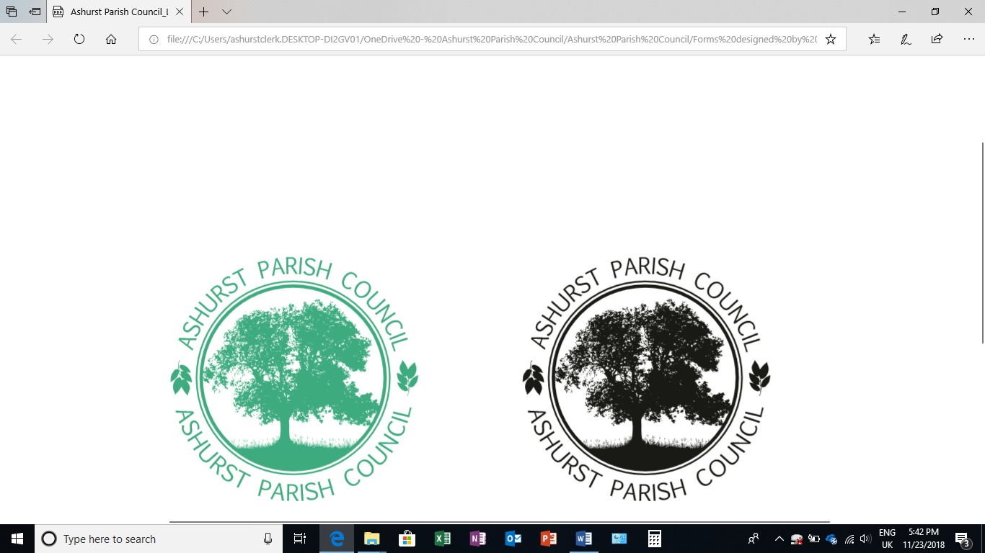 | Clerk to the Council: Emily Simpson  Tel: 07881714516  e-mail: ashurstclerk@outlook.com

Asset List as of 19.03.2025

Asset | Date acquired | Purchase value | Replacement cost | Notes
Notice Board | Pre 2016 | £800 | £800
Laptop | July 2016 | £383.94 | £383.94
Projector | Nov 2016 | £237.49 | £237.49

True value (as not to record purchase value): £1421

- Notice board as attached to Ashurst Village Hall, Horsham Road, Ashurst, West Sussex.
- HP Laptop for council use – kept at the clerk’s home address.
- Projector for use in meetings – stored at the home of Cllr Les Nicholson

There have been no additions or deletions since 31 March 2024.

