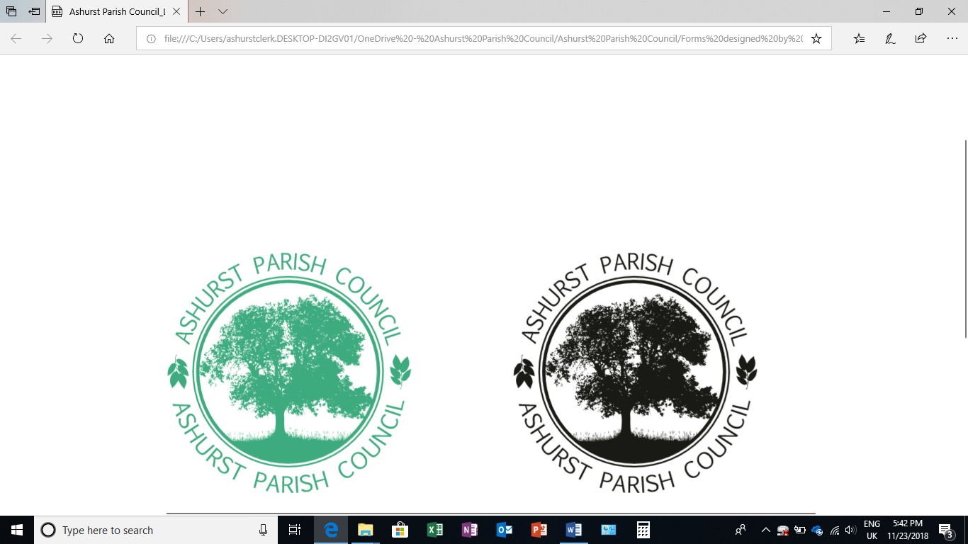 | Clerk to the Council: Oliver Last  e-mail: ashurstclerk@outlook.com

TO: ALL MEMBERS OF ASHURST PARISH COUNCIL
Councillors are respectfully summoned to attend the Annual Meeting of Ashurst Parish Council on Thursday 15th May 2025 at 6.30pm at Ashurst Village Hall for the transaction of the business on the Agenda below.
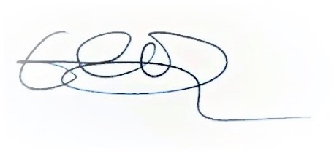
Oliver Last
Clerk to the Council
9th May 2025

AGENDA
- Election of Chair and Vice Chair
- To elect a Chair for the next Council year
- To elect a Vice Chair for the next Council year

- Attendance and Apologies for Absence
To accept apologies for absence

- To Receive Declarations of Interest, Notification of Changes to Members’ Interests and consider any requests for a dispensation
To receive any declarations of interests from Members in respect to items on the agenda.

- Appointments to outside bodies
To confirm any councillor appointments to outside bodies, including WSALC, HALC, HDC Climate Rep and Climate Action Group.

- Public Session (members of the public may speak for up to 5 minutes at the discretion of the Chair about items on the agenda).

- Approval of the Minutes of the Meeting of the Parish Council held on 20th March 2025*
To review and approve.

- District Councillor Reports
To receive any reports.

- HALC Update
To receive an update from the Chair.

- Certificate of Exemption
To approve the Certificate of Exemption from external audit for the Annual Governance and Accountability Return for 2024/25.

- Annual Governance and Accountability Return (AGAR) *
- Internal Audit Report
To review and approve
- Section 1 of the AGAR
To review and approve
- Section 2 of the AGAR
To review and approve
- Notice of electors’ rights
To confirm dates

- To review any recommendations made by the Internal Auditor
To discuss and agree any recommendations made by the auditor.

- Insurance Renewal
To review the insurance renewal quote; current insurance expires 1st June 2025*

- Review the Standing Orders*
To review and approve the recently amended Standing Orders

- Planning Applications
- Review any planning applications received since the publication of the agenda

- Planning Decisions from HDC
To receive decisions on planning applications from Horsham District Council.

- Payments and bank reconciliation*
Review schedule of payments and bank reconciliation since the last meeting (March 20th) and to note the remaining balance of the PWLB loan.

- Recreation Ground
- To receive a report on the Recreation Ground Trust’s income and expenditure since the last meeting (March 20th).*
- To approve setting up a direct debit for water rates (Business Stream)
- To review 2025/26 contract and charge for Ashurst United Football Club to hire the Recreation Ground
- To receive an update on the rebuild/replacement of the John Eaton Hut.
- To receive a general update on the Recreation Ground.

- Speedwatch and Speed Restrictions within the Parish
- To receive an update on any recent developments.

- Operation Watershed
To receive and, if considered appropriate, approve an application to Operation Watershed.

- To agree a revised date for the Annual Parish Meeting.

Next meeting date: 17th July 2025

*Documents circulated with the agenda

