Clerk to the Council: Emily Simpson
Tel: 07881714526
e-mail: ashurstclerk@outlook.com

TO: ALL MEMBERS OF ASHURST PARISH COUNCIL

Councillors are respectfully summoned to attend the meeting of Ashurst Parish Council on Thursday 16th March 2023 at 7.30pm at Ashurst Village Hall for the transaction of the business on the Agenda below.

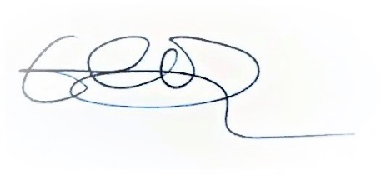
Emily Simpson
Clerk to the Council
10th March 2023

AGENDA

To discuss any questions submitted by the public.

- Apologies for Absence.
- Declaration of Members’ Interests, notification of changes to Members’ Interests, and consideration of any requests for dispensation.
- Approve the Minutes of the meeting of 19th January 2023*: The minutes, subject to any amendments, to be approved and signed as a true record of the meeting.
- Reports from District & County Councillors.
- Outstanding Actions: To report on actions brought forward from the last meeting.
- Recreation Ground Matters:
- To receive a report on the Recreation Ground Trust’s income and expenditure for the period from 21st September 2022 to 20th January 2023.
- To discuss moving banks from HSBC to Lloyds.
- To receive an update on grass cutting.
- To receive an update on Ashurst United FC.
- To receive an update on the energy contract with EDF.
- To receive an update on the tree for the Queen’s Green Canopy.
- To receive an update on the rebuild/replacement of the John Eaton Hut.

- Planning Applications

To comment on planning applications received from Horsham District Council.

- Planning Decisions from HDC

To receive decisions on planning applications from Horsham District Council.

- Payments and bank reconciliations

(a)To review the schedule of payments since the last meeting (19th January 2023) and the latest bank reconciliation*

(b)To receive a report on the Council’s income*

- Policies*

(a) To review and adopt the Lone Worker policy

(b) To review and adopt the Equal Opportunities policy

(c) To review and adopt the Council’s Documents and Records retention policy

(d) To review and adopt the Council’s Publication Scheme

(e)To review and adopt the Co-option policy

(f) To review and adopt the GDPR Impact assessment

(g) To review and adopt the General Privacy policy

(h) To review and adopt the Staff & Councillor Privacy policy

- Elections

To receive an update on the upcoming elections.

- HALC Update

To receive a general update from Cllr Fischel.

- Rampion

To receive any update on Rampion.

- GDPR

Reminder to delete all emails over 6 months old.
- Correspondence

To discuss recent significant correspondence, either by letter or email, and respond as appropriate.
- Reports from Outside Bodies
- Information Items

To receive information and items for the agenda of future meetings.

- Annual Parish Meeting

To propose and agree a date for the annual parish meeting.

- King’s Coronation

To discuss any plans to celebrate the King’s Coronation.

Date of the next Meeting of the Council: Annual Council Meeting 18th May 2023

*Documents attached

