Clerk to the Council: Emily Simpson
Tel: 07881714526
e-mail: ashurstclerk@outlook.com

TO: ALL MEMBERS OF ASHURST PARISH COUNCIL

Councillors are respectfully summoned to attend the meeting of Ashurst Parish Council on Thursday 4th January 2024 at 7.30pm at Ashurst Village Hall for the transaction of the business on the Agenda below.

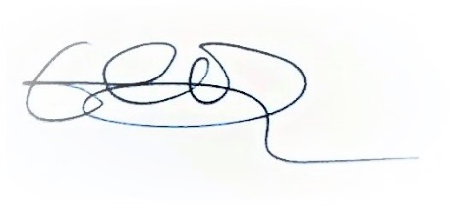
Emily Simpson
Clerk to the Council
29th December 2023

AGENDA

To discuss any questions submitted by the public.

- Apologies for Absence.
- Declaration of Members’ Interests, notification of changes to Members’ Interests, and consideration of any requests for dispensation.
- Approve the Minutes of the meeting of 16th November 2023* The minutes, subject to any amendments, to be approved and signed as a true record of the meeting.
- Reports from District Councillors
- Recreation Ground Matters:
- To receive and approve a report on the Recreation Ground Trust’s income and expenditure since the last meeting (16th November 2023)
- To receive an update on HSBC and LLoyds
- To receive an update on the rebuild/replacement of the John Eaton Hut.
- To receive an update on the Football Club.

- Broadband in Ashurst

To receive an update on Broadband in Ashurst.

- Planning Applications

To comment on planning applications received from Horsham District Council.

- Planning Decisions from HDC

To receive decisions on planning applications from Horsham District Council.*

- Planning Appeals

To consider any planning appeals.

- Payments and bank reconciliations

(a) To review and approve the schedule of payments since the last meeting (16th November 2023) and the latest bank reconciliations (December 2023)*

(b) To receive a report on the Council’s income since the last meeting (16th November 2023)

- Budget 2024-25

To consider and approve the budget for 2024-25*

- WSALC/NALC Update

To receive any updates.

- HALC Update including Local Plan

To receive an update from Cllr Fischel.

- Speeding in Ashurst
(a) To receive an update from Speedwatch (b)To discuss Ashurst Parish Council’s proposal for the implementation of a 40mph speed limit north of the village
- Rampion

To receive an update on Rampion.

- Grants

To consider any grant applications.

- GDPR

Reminder to delete all emails over 6 months old.
- Correspondence

To discuss recent significant correspondence, either by letter or email, and respond as appropriate.
- Reports from Outside Bodies

- Information Items

To receive information and items for the agenda of future meetings.

- Future meeting dates for 2024

To propose and agree Council meeting dates for the year ahead.*

*Documents attached or sent previously

