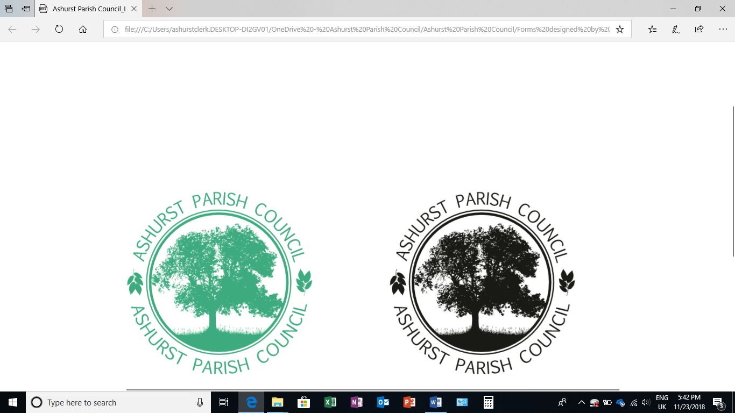 | Clerk to the Council: Oliver Last  e-mail: ashurstclerk@outlook.com

MINUTES OF THE ANNUAL MEETING OF ASHURST PARISH COUNCIL, HELD AT ASHURST VILLAGE HALL ON THURSDAY 15TH MAY 2025 AT 6.30PM
Attendance:
Ashurst Parish Council (APC) | Cllr Fischel (Chair), Cllr Hammond, Cllr Knight, Cllr Nicholson and Cllr Russell (Vice Chair)
Horsham District Council (HDC) | District Cllr Finnegan
Clerk | Oliver Last
Public | 1

- Election of the chair and Vice Chair
- Cllr Russel Nominated Cllr Fischel as Chair for the municipal year 2025/26
- Cllr Knight Nominated Cllr Russell as Vice Chair for the municipal year 2025/26
- Attendance and Apologies for Absence
There were no apologies received.
- To Receive Declarations of Interest, Notification of Changes to Members’ Interests and
consider any requests for a dispensation
Councillors were reminded to return any revised Declarations of Interest, as defined under the Localism Act 2011, if they hadn’t already done so.
There were no declarations of interest on any agenda items in this meeting.
- Appointments to outside bodies
Cllr Fischel and Cllr Russell were selected as spokespersons for WSALC and HALC.
Cllr Knight was selected as spokesperson for HDC Climate and the Climate Action Group.
Cllr Nicholson was selected as spokesperson for Police Liaison and Speed Watch.

- Public Session (members of the public may speak for up to 5 minutes at the discretion of the Chair about items on the agenda).
There were no members of the public who wished to speak.

- Approval of the Minutes of the Meeting of the Parish Council held on 20th March 2025*
Councillors RESOLVED to approve the last meeting’s minutes as a true and accurate record.

- District Councillor Reports
Cllr Finnegan provided an update on district-level housing developments within the area, including information on outreach services currently being delivered by Adur District Council (ADC), such as the Wellbeing Walks initiative. Councillors were also informed that rural communities funding is available locally to support small businesses.
An overview of the current position regarding the Local Plan was presented. Cllr Finnegan reported that, following four months of engagement, the Planning Inspector had recommended the withdrawal of the Plan. This decision was largely attributed to Horsham District Council's (HDC’s) unwillingness to take on additional numbers required for Crawley Borough Council.
Cllr Finnegan also provided a summary on the ongoing discussions concerning devolution and the potential creation of a unitary authority. Communication across local authorities remains positive. Four potential structural options are currently under consideration:
- A single, large unitary authority covering the whole area;
- A North/South split;
- An East/West division;
- A North/South split with Crawley and Brighton operating separately.
At present, no timeline has been confirmed for the next update on these proposals.
Finally, Cllr Finnegan informed the meeting that she is currently serving on the Policy and Scrutiny Committee at HDC, which is presently reviewing the Council’s assets.
- HALC Update

Cllr Fischel provided a brief update following attendance at a recent inter-parish meeting where the potential move towards a unitary authority was discussed. It was noted that while discussions are ongoing, there have been minimal substantive updates to report at this stage.

- Certificate of Exemption
The Clerk provided an overview of the Certificate of Exemption as part of the Annual Governance and Accountability Return (AGAR). The Council meets the qualifying criteria for exemption from a limited assurance review by an external auditor, as both its annual gross income and expenditure are below the £25,000 threshold. As such, the Council certified itself as exempt.

- Annual Governance and Accountability Return (AGAR) *
- Internal Audit Report
The Internal Audit was reviewed and approved.
- Section 1 of the AGAR
Section 1 of the AGAR was reviewed and approved.
- Section 2 of the AGAR
Section 2 of the AGAR was reviewed and approved.
- Notice of Electors’ Rights
The dates for the Notice of Electors’ Rights were agreed as Tuesday 3 June 2025, ending Monday 14 July 2025.

- To review any recommendations made by the Internal Auditor
The recommendations provided by the Internal Auditor were reviewed by the Council and agreed to be implemented as part of ongoing improvements to governance and financial procedures, including the requirement to post supporting documents alongside agendas.

The Council also wished to record its sincere thanks to Emily Simpson, the previous Clerk, for her dedication and hard work during her time in the post.

- Insurance Renewal
The Council discussed the forthcoming insurance renewal. It was agreed that the Clerk was authorised to arrange the renewal of the Council's insurance policy, subject to the total premium not exceeding £450, and subject to consultation and agreement with the Chair.

- Review the Standing Orders
The Council reviewed NALC’s proposed updates to the Standing Orders. It was agreed to proceed with the updates, while retaining the original meeting times etc. as previously set.

- Planning Applications
There were no planning applications.

- Planning Decisions from HDC
There were no planning decisions.

- Payments and bank reconciliation*
The Clerk provided Councillors with a breakdown of all income and expenditure for the Parish Council since 20th March (see Appendix 1). All transactions were reviewed and approved by the Council. The Clerk also reported a remaining balance of £39,000 to the Public Works Loan Board (PWLB) loan, which was duly noted by Councillors.

- Recreation Ground
- The Clerk provided a breakdown of all income and expenditure relating to the Recreation Ground since 20th March, (see Appendix II). The financial report was reviewed and approved by the Council.

Cllr Fishel agreed to investigate options for improving the future proofing of the Recreation Ground and will report back with findings and recommendations.

- It was agreed that the Council will not proceed with setting up a direct debit for utility payments at this time. Instead, meter readings will be taken manually, and photographic evidence will be submitted as required.

- Since the John Eaton Hut would still have to be used this coming year, it was agreed to issue a new contract for the Ashurst footballers without any amendments to the existing terms and conditions.

- Cllr Fischel presented updated draft plans and proposals for the new sports building. These were reviewed and discussed by the Council. It was hoped to hold a public consultation on these plans at the forthcoming Annual Parish Meeting.

- An update was received explaining that, with the exception of the large oak tree, the trees and hedges were doing well.

- Speedwatch and Speed Restrictions within the Parish

Cllr Nicholson provided an update, confirming that there have been no changes since the last report. A meeting has been scheduled to discuss the TRO relating to the speed signs.

- Operation Watershed
Cllr Knight gave an update on Operation Watershed and it was agreed to request a quote for the proposed drainage works at the site in question on Peppers Lane. Cllr Knight agreed to take this matter forward. The proposal includes draining runoff onto adjacent farmland. A site meeting with West Sussex County Council (WSCC) and Landbuild is planned to discuss the details.

- To agree a revised date for the Annual Parish Meeting.

Provisional date set for 18th June 2025 at 6pm.
Post meeting note: The revised date is set for 23rd July at 6.pm.

There being no further business the meeting closed at 20:14.

Appendix 1 APC Account
Schedule of payments since the last meeting (20th March 2025)
14 April 25 | Emily Simpson | Yola Mcrsft Charge | £166.33
22 April 25 | Service Charges | Bank | £4.25
23 April 25 | Emily Simpson | Yola Reimbursement | £155.40
25 April 25 | HMRC |  | £133.00
09 May 25 | HMRC |  | £66.40
12 May 25 | Emily Simpson | Salary May 1 Week | £66.43
12.05.25 | Emily Simpson | Salary April | £265.75
Total Payments |  |  | £857.56

Schedule of receipts since the last meeting (20th March 2025)
28 April 25 | Horsham DC | ½ Annual Precept | £7,330.00
14 May 25 | HMRC Vtr Xgv | VAT returns | £498.26
Total Receipts |  |  | £7,828.26

Bank Reconciliation as at 15th May 2025
Balance per Bank Statement | £24,305.17
Add: Outstanding receipts | 0.00
Less: Outstanding payment | 0.00
Net balance | £24,305.17
Cashbook balance as at 20th March 2025 | £17,334.47
Plus Receipts for the period | £7,828.26
Less Payments for the period | (£857.56)
Cashbook Balance as at 15th May 2025 | £24,305.17

Appendix 2 Recreation Ground Account
Schedule of receipts since the last meeting (20th March 2025)
28 March 25 | EDF |  | £60.00
14 April 25 | HDC | Playground Insp | £72.00
14 April 25 | Business Stream |  | £67.81
23 April 25 | HDC Rates 25/26 |  | £98.80
28 April 25 | EDF |  | £60.00
12 May | HDC | Playground Insp | £72.00
Total Payments |  |  | £430.61

Schedule of receipts since the last meeting (20th March 2025)
Total Receipts | 0.00
Cashbook balance as at 20th March 2025 | £11,595.87
Less Payments for the Period | (£430.61)
Cashbook balance as at 15th May 2025 | £11,165.26

