 | Clerk to the Council: Oliver Last  e-mail: ashurstclerk@outlook.com

MINUTES OF THE MEETING OF ASHURST PARISH COUNCIL, HELD AT ASHURST VILLAGE HALL ON THURSDAY 8th January 2026 AT 7.30PM
Attendance:
Ashurst Parish Council (APC) | Cllr Fischel (Chair), Cllr Russell (Vice Chair), Cllr Knight, Cllr Bunce and Cllr Nicholson
Horsham District Council (HDC) | District Cllr Finnegan
Clerk | Oliver Last
Public | 0

The Chair welcomed everyone to the meeting.
- Apologies for Absence

Apologies were received from Cllr. Hammond and District Cllr Marks.
79. Declarations of interest
Councillors were reminded to return any revised Declarations of Interest, as defined under the Localism Act 2011. There were no Declarations of Interest on any agenda items in this meeting.

- Public forum and questions
There were no members of public questions.
- Approval of the Minutes of the Meeting of the Parish Council held 20th November 2025.
It was resolved to approve the minutes from the last meeting held on 20th November 2025 as a true and accurate record.
- District Councillor Reports
Cllr Finnegan provided the Council with an update on the Local Government Reorganisation (LGR), which will replace the current county, district and borough arrangements with new unitary authorities. Surrey is progressing on an accelerated timetable, with shadow elections in May 2026 and new councils becoming operational on 1 April 2027. For West Sussex and other areas, government decisions on future council structures are expected in early 2026, with vesting day set for 1 April 2028 and shadow authority elections in May 2028. West Sussex County Council favours a three-unitary model (West Sussex, East Sussex, and Brighton & Hove), while the seven district councils support splitting West Sussex into two unitaries. Public consultation is taking place through the Shaping West Sussex engagement.
The update also covered related governance and service matters. Mayoral elections have been postponed to May 2028 to align with the LGR timetable, although there is ongoing discussion about bringing elections forward to 2027.

Key service updates include the introduction of food waste collections from 1 April, progress on accelerating the local plan timetable (including housing numbers and biodiversity net gain requirements), and town council changes, with Horsham Town Council covering ‘unparished’ areas and Steyning expected to adopt town status in May 2026.

Cllr Finnegan also shared the sad news of the untimely death of Helen Peacock a valued member of HDC. She will be sorely missed.

- Conservation and Biodiversity Initiatives
The Council received an update on the Weald to Wave project. It was noted that individuals are able to sign up to the initiative independently and may contribute by inputting environmental data from their own gardens.
The Council agreed that information about the project would be shared via the Council website, Parish Newsletter and Noticeboard in order to encourage public participation and awareness.
It was resolved that the Council acknowledge the update regarding the Weald to Wave project and support the promotion of public participation by sharing relevant information through Council communication channels. Cllr Knight would provide an update for the forthcoming Newsletter.

- HALC/Devolution and Local Government Reorganisation
Cllr Fischel informed the Council that she would be attending the next HALC meeting being held on Thursday 12th February.

- Planning Applications

The following planning application was discussed:
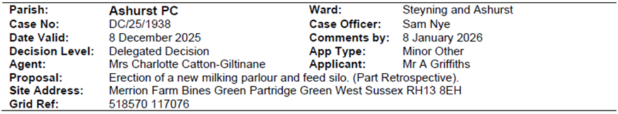

It was resolved to acknowledge the application.

- Planning Decisions from HDC

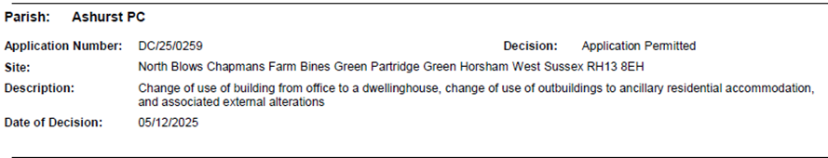
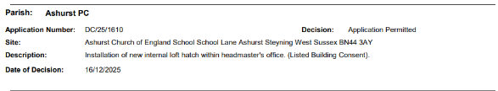

The decisions were noted.

- Payments and bank reconciliation
The Clerk updated the Council on the income and expenditure for this period (See Appendix 1).
- Budget
The Clerk presented the Councillors with last year's budget and the proposed budget lines for the coming year. These were discussed and it was felt that a general increase of 5% should be applied to the appropriate budget lines affected by inflation and to increase the Recreation Ground grant by this amount as well.

The council discussed the current PWLB loans and grants.

It was resolved to agree to the proposed budget.

- Precept
The Clerk updated the Council with the proposed Precept increase in line with the agreed budget. The 2026/7 precept request was for £15,214, being a 3.8% increase from last year.

It was resolved to accept this Precept increase.

- Recreation Ground
- The Clerk gave an update on the income and expenditure on the Recreation Ground account for the period (See Appendix 2).

- To receive an update on the rebuild/replacement of the John Eaton Hut.
The Council agreed that the community consultation, which included the distribution of a survey, public meetings, inclusion of the matter on all Council meeting agendas in recent years, and the provision of opportunities for residents to meet with councillors, had now been completed.
Preferences expressed in the results of the consultation were summarised as:
- The ‘spectator area’ - both inside and out - and the kitchen facility, as provided by the existing Cricket Pavilion, should remain in their current location.
- The current space of the Cricket Pavilion is also appreciated.
- Improvements to the sports provision should be kept simple.
- There were a number of requests for extra parking.

A general discussion ensued on how to accommodate these preferences and how to move this project forwards. The following points were covered:
- Our overriding constraint is the funding of the project.
- Potential fundraising options and the need to involve Ashurst Residents and the main stakeholders in this exercise.
- Consideration of a simplified, easy-to-maintain, sports building to replace the John Eaton Hut in its current location (as, given the existence of drainage limitations, the siting of toilets and showers needs to be within the current footprint of the Hut).
- We would keep the idea of an externally accessed toilet for public/school use.
- The feasibility of renovating the current Cricket Pavilion, rather than looking to replace it with a new building on that site, given the likely considerable cost differential, should be reconsidered.
- The need to obtain clarification from Planning regarding the possible provision of up to six parking spaces, noting that no tarmac or similar surfacing is proposed.
- Additional storage is required – for netting etc. currently stored in the Pavilion.
(The school storage building should remain as is, ideally in its current location, unless it proves necessary to move it.)
It was resolved that the Council acknowledged the completion of the community consultation. The consultation outcomes would be circulated by way of the forthcoming Newsletter, together with a request for anyone wishing to get involved in fundraising to make themselves known.
Continuing enquiries would be made regarding a modified design and costings for a simplified sports building to replace the John Eaton Hut, together with ball park figures for the anticipated cost of renovating the Cricket Pavilion.
Advice would also be sought from Horsham Planning, as well as from the Charity Trustees of the Recreation Ground, in relation to the proposed additional parking spaces. (It being noted that the Council does not wish to encroach on any green space in the Recreation Ground).
- To receive a general update on the Recreation Ground.
Cllr Russell updated the Council on the playground training. It was agreed that future inspections should be paid for and made by a suitably qualified organisation.
- Speedwatch and Speed Restrictions within the Parish Cllr Nicholson agree to try and arrange a meeting between himself, the Clerk and Highways in order to try and reach a satisfactory solution re agreeing the placement of the poles required to put up a SID.

Cllr Nicholson would report the broken SID.

It was resolved to note the update.

- Operation Watershed Cllr Knight is due to meet with WSCC Highways regarding the drainage issues on Peppers Lane/Honeybridge Lane.

It was resolved to note the update.

- Road signs Preventative measures for the junction of Honeybridge Lane and Peppers Lane were discussed.
The issue had already been resolved by WSCC with the installation of additional signage and chevrons.
The Clerk would order a replacement Grit Bin for the broken bin on the Church Lane/School Lane/Peppers Lane junction.
It was resolved to note the update.

- Government email addresses
The Clerk had supplied the councillors with information sent from the preferred supplier, Parish Online, and asked for questions.

The anticipated costs are as follows:

It was resolved to proceed with the email and website changes once a meeting has been arranged with Cllr Bunce. If other councillors had any questions or ideas regarding the website they should e-mail the Clerk. It was agreed that the new domain name would be ‘ashurstparish.gov.uk’.

- Correspondence
An updated acceptance of office forms are to be sent to all councillors for completion. These will then be reissued to HDC.

- Forthcoming Dates - To be confirmed:
5th March at 7.30pm

The meeting ended at 21:39.

Appendix 1

Appendix 2

