 | Clerk to the Council: Oliver Last  e-mail: ashurstclerk@outlook.com

MINUTES OF THE MEETING OF ASHURST PARISH COUNCIL, HELD AT ASHURST VILLAGE HALL ON THURSDAY 5th March 2026 AT 7.30PM
Attendance:
Ashurst Parish Council (APC) | Cllr Fischel (Chair), Cllr Russell (Vice Chair), Cllr Knight, Cllr Bunce, Cllr Hammond
Horsham District Council (HDC) | District Cllr Finnegan, Cllr Marks
Clerk | Oliver Last
Public | 0

The Chair welcomed everyone to the meeting.
- Apologies for Absence

Apologies were received from Cllr Nicholson.
98. Declarations of interest
Councillors were reminded to return any revised Declarations of Interest, as defined under the Localism Act 2011.
There were no Declarations of Interest on any agenda items in this meeting.

- Public forum and questions
There were no members of public questions.
- Approval of the Minutes of the Meeting of the Parish Council held 8th January 2026.
It was resolved to approve the minutes from the last meeting held on 8th January 2026 as a true and accurate record.
- District Councillor Reports
Cllr Marks updated the Council on the introduction of food‑waste bins from the middle of March, which are expected to reduce current food‑waste levels by around 40%. He also reported on the Steyning Grammar School rebuild, noting that the public consultation is now available online via the SGS Consultation – New Build – Steyning Grammar School page. Further updates included information on Easy Fundraising initiatives supporting community projects, the Rampion Fund opening on 14 April through the Sussex Community Foundation website, and the Community Climate Fund, which is available for water‑saving initiatives. Cllr Finnegan informed the Council that County Council elections will resume in May, with the purdah period beginning at the end of March. Confirmation of which option will be adopted for the Local Government Reorganisation (LGR) is expected between 11-17th March (probably 16th) but there may be some delays. The Brighton option was currently looking strong. Cllr Finnegan also noted that Local Plan inspectors are revisiting the Horsham Plan, with discussions at HDC to be live‑streamed. The revised National Planning Policy Framework (NPPF) is open for comment until 10 March. The peer review has already taken place, and the initial results were very positive. Work on communication with rural populations may be required. A community governance review will be issued and reviewed by HDC, and then shared with the community for further feedback.

- Conservation and Biodiversity Initiatives
Councillors discussed the option for the Recreation Ground to join the Weald to Wave project. They further discussed dates for a Village litter pick and agreed to meet on Sunday 29th March at 10am at the Village Hall. Cllr Russell would bring spare high vis jackets, gloves and bin liners – both ordinary and green.
It was resolved that the Recreation Ground would join the Weald to Wave project.

- HALC/Devolution and Local Government Reorganisation
Cllr Fischel updated the Council following a meeting attended on Thursday, 12 February, providing information on the proposed changes to the NPPF and the ongoing LGR (see also the District Councillors update in 101 above). In particular the new NPPF will be providing guidelines and a minimum standard for most planning issues, ie there will be a loss of decision making for individual Neighbourhood Plans.
The Clerk then informed the Council of the Community Governance Review being completed by Horsham District Council and went through the report supplied, confirming the input required by parish councillors and the potential outcomes of the review. Of particular concern to Ashurst was the possible recommendation that smaller Parish Councils should cluster with others. There is information on HDC’s website regarding progress on all of these issues.

It was resolved to note the update.

- Planning Applications

The following planning application was discussed:

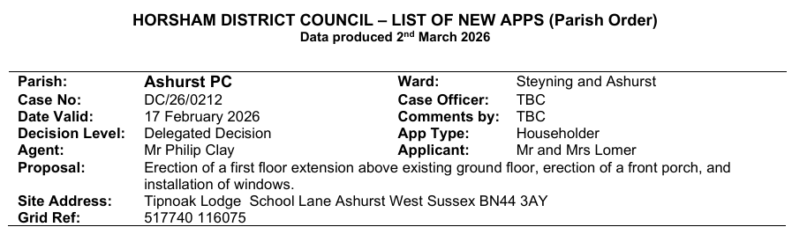

It was resolved to acknowledge the application.

- Planning Decisions from HDC
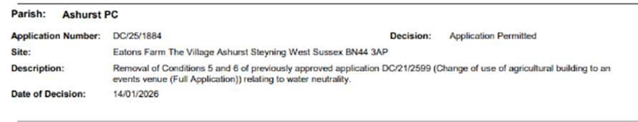
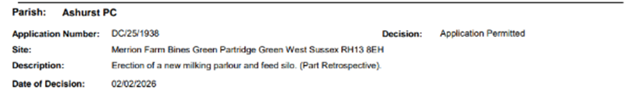
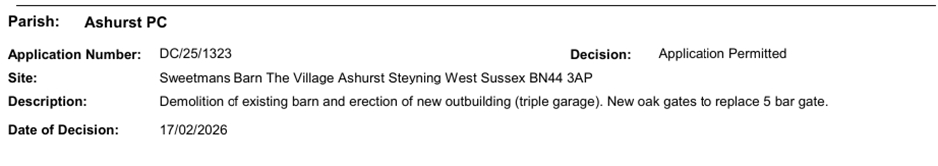

The decisions were noted.

- Payments and bank reconciliation
The Clerk provided an update on the Council’s payments and bank reconciliation, confirming that all income and expenditure for the period had been reviewed and recorded accurately and that the bank reconciliation had been completed with no discrepancies identified. Current balances were verified against bank statements.

It was resolved to approve the schedule of payments since the last meeting (see Appendix 1) and the bank reconciliation to 5th March 2026.

- Recreation Ground
- The Clerk provided an update on the Council’s payments and bank reconciliation, confirming that all income and expenditure for the period had been reviewed and recorded accurately and that the bank reconciliation had been completed with no discrepancies identified. Current balances were verified against bank statements.

It was resolved to approve the schedule of payments since the last meeting (see Appendix 2) and the bank reconciliation to 5th March 2026.

- To receive an update on the rebuild/replacement of the John Eaton Hut.

It was confirmed that a summary of the results of the questionnaire (as noted in the last minutes) will be included in the upcoming Parish Newsletter, along with a request for volunteers to contact the Clerk if they would like to assist with fundraising.
It was further agreed that a more detailed analysis of the results of the questionnaire would be put on the website for any interested residents to refer to.

A pre‑application will be required for any car park extension.

The Council also discussed the option of commissioning structural engineers to dig test pits to assess the depth and condition of the existing footings. It was felt that there was no need to test the John Eaton Hut as this would be done anyway prior to any building work taking place. In the case of the Cricket Pavilion, it was decided to wait to find out what costs would be involved before any decision was made.

It was noted that a previous asbestos survey has already been completed, with no asbestos having been found.

It was resolved to wait for a costing before making a decision to dig test pits.
- To receive a general update on the Recreation Ground.

The grass‑cutting contract has now come to an end, and a new tender will need to be issued, with several details requiring amendment before it is released. It was confirmed that a weekly visual inspection of the play area will be carried out by Cllrs Russell and Fischel, with findings recorded on a monitoring sheet. In addition to these internal checks, the Clerk will arrange for both quarterly and annual inspections to be completed to ensure full compliance and safety oversight.

It was resolved to note the update.

- Speedwatch and Speed Restrictions within the Parish
Unfortunately, the WSCC officer could not attend this meeting but will be invited back to speak at the next one.

- Operation Watershed
WSCC has now supplied plans to relieve the flooding at two sites on Peppers Lane. The works will need to be agreed by the relevant landowners as the drainage will require private and riparian ditches.

It was resolved to note the update.

- Defib Grant
A request was received from the Steyning Area First Responders for a grant contribution towards the defibrillator, and the Council discussed the application.

It was resolved to agree to pay the grant for the Defib of £125.

- Government email addresses and website
Cllr Bunce updated the Council on his recent discussion with the new website provider and confirmed that he was satisfied with the proposed design and functionality, recommending that the Council proceed with the development of the new website. Green was to be adopted as the colour and an aerial photo of the centre of the village was to be sought.

It was resolved to proceed with the new website and the new councillor email addresses.

- Correspondence
There was no additional correspondence.

- Forthcoming Dates

28th May – Invite George WSCC to talk, 7pm, Parish AGM, 7:30pm start.

Proposed future meeting dates – NB Clerk to send out invites. Dates TBC’

16th July 6:00 - Annual Parish Meeting, Full Council Meeting, 7.30pm start.
24th September - Recreation Ground AGM, 6.30pm TBC , Full Council, 7:30pm.
26th November - Full Council Meeting 7.30pm.
14th January - Full Council Meeting 7.30pm.
18th March - Full Council Meeting 7.30pm.

There being no further business the meeting ended at 21.13.

