ASHURST PUBLIC RECREATION GROUND TRUST
Telephone: 07881 714526 email: ashurstclerk@outlook.com

ASHURST RECREATION GROUND TRUST AGM TO BE HELD ON THURSDAY 21st SEPTEMBER AT 7.00PM AT ASHURST VILLAGE HALL
ALL MEMBERS OF THE PUBLIC ARE WELCOME TO ATTEND

1. Apologies for Absence
2. Declaration of Members’ Interests
3. To Approve the Minutes of the Meeting of Thursday 24th November 2022
4. Update on actions from the last AGM
5. Accounts
6. Reports
i) Primary School
ii) Cricket Club
iii) Football Club
7. Update on trees
8. Update on Ground and Buildings
9. Questions from the floor
10. Any other business
11. Date of the next AGM: to be confirmed
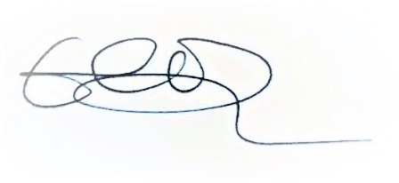
Emily Simpson
Secretary to the Trust

